

**Sambalpur University Institute of Information Technology**

**Subject** - Designing college website and registration/Login for Alumni of Sambalpur University institute of Information technology using MVC

**Name: - Abhishek Kumar Gupta**

**Registration No: - 10025/19**

**Branch: - Computer Science Engineering**

**Academic Year: - 2019-2023**

**ACKNOWLEDGEMENT**

I express my deepest thanks to N.R. Nayak Sir (The Head of IT Department) for taking part in useful decision & giving necessary advices and guidance and arranged all facilities to make life easier. I choose this moment to acknowledge his/her contribution gratefully.

It is my radiant sentiment to place on record my best regards, deepest sense of gratitude to Mr Arka Samanta (Application Developer in IT Department) Mr Nitesh Ku. Mahapatra Sir (The Trainee Application Developer in IT Department) in the IFFCO for their careful and precious guidance which were extremely valuable for my Internship

I perceive as this opportunity as a big milestone in my career development. I will strive to use gained skills and knowledge in the best possible way, and I will continue to work on their improvement, in order to attain desired career objectives. Hope to continue cooperation with all of you in the future.

Sincerely,

Abhishek Kumar Gupta

IFFCO, Paradeep

Date:

**ABOUT IFFCO**

**Indian Farmers Fertiliser Cooperative Limited**, also known as **IFFCO**, is [a multi-state cooperative](https://en.wikipedia.org/wiki/Government_of_India) society. IFFCO is wholly owned by Cooperative Societies of India. The society is engaged in the business of manufacturing and marketing of [fertilizers](https://en.wikipedia.org/wiki/Fertilizer). IFFCO is headquartered in [New Delhi](https://en.wikipedia.org/wiki/New_Delhi), India. Started in 1967 with 57 member cooperatives, it is today the biggest co-op in the world by turnover on [GDP](https://en.wikipedia.org/wiki/Gross_domestic_product) per capita (as per World Cooperative Monitor 2021), with around 35,000 member cooperatives reaching over 50 million Indian farmers.

With around 19% market share in [urea](https://en.wikipedia.org/wiki/Urea) and around 31% market share in complex fertilizers (P2O5 terms) IFFCO is India's largest fertilizer manufacturer.

The cooperative was ranked 66th on the [Fortune India 500](https://en.wikipedia.org/wiki/Fortune_India_500) list of India's biggest corporations as of 2017 with a net worth of $2.6 billion as on March, 2021.

**PLANTS**

* [Kalol](https://en.wikipedia.org/wiki/Kalol,_Gandhinagar), [Gujarat](https://en.wikipedia.org/wiki/Gujarat): Commissioned in 1975 and expanded in 1997, it produces [ammonia](https://en.wikipedia.org/wiki/Ammonia) (1100 MTPD) and [urea](https://en.wikipedia.org/wiki/Urea) (1650 MTPD).
* [Kandla](https://en.wikipedia.org/wiki/Kandla), [Gujarat](https://en.wikipedia.org/wiki/Gujarat): Commissioned in 1975 and first expanded in 1981 and again in 1999, it produces [NPK](https://en.wikipedia.org/wiki/NPK) (10:26:26; Capacity 520,000 MTPD), NPK (12:32:16; Capacity 700,000 MTPD), NP (20:20:0:13), [DAP](https://en.wikipedia.org/wiki/Diammonium_phosphate) (18:46:0; Capacity 1,200,000 MTPD) and water-soluble fertilisers.
* [Phulpur](https://en.wikipedia.org/wiki/Phulpur,_Allahabad), [Uttar Pradesh](https://en.wikipedia.org/wiki/Uttar_Pradesh): Commissioned in 1981 and expanded in 1997, it produced [ammonia](https://en.wikipedia.org/wiki/Ammonia) (9.7 lakh MT) and [urea](https://en.wikipedia.org/wiki/Urea) (17 lakh MT).
* [Aonla](https://en.wikipedia.org/wiki/Aonla_(Assembly_constituency)), [Uttar Pradesh](https://en.wikipedia.org/wiki/Uttar_Pradesh): Commissioned in 1988 and expanded in 1996, it produced [ammonia](https://en.wikipedia.org/wiki/Ammonia) (1740 MTPD) and [urea](https://en.wikipedia.org/wiki/Urea) (1515 MTPD).
* [Paradeep](https://en.wikipedia.org/wiki/Paradip), [Odisha](https://en.wikipedia.org/wiki/Odisha): Taken over in 2005, it produces [phosphoric acid](https://en.wikipedia.org/wiki/Phosphoric_acid) (8,75,000 MTPA), [sulphuric acid](https://en.wikipedia.org/wiki/Sulfuric_acid) (23,10,000 MTPA), [NPK](https://en.wikipedia.org/wiki/NPK) (10:26:26), NPK (12:32:16), NP (20:20:0:13) and [DAP](https://en.wikipedia.org/wiki/Diammonium_phosphate) (18:46:0) grade of fertilisers.

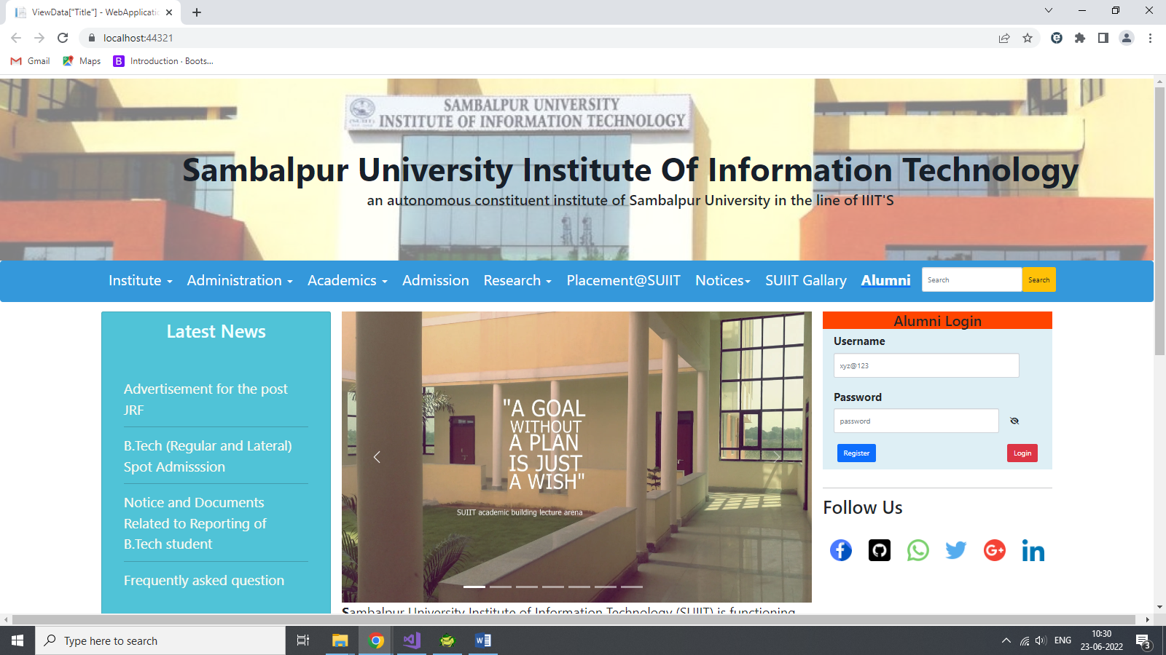

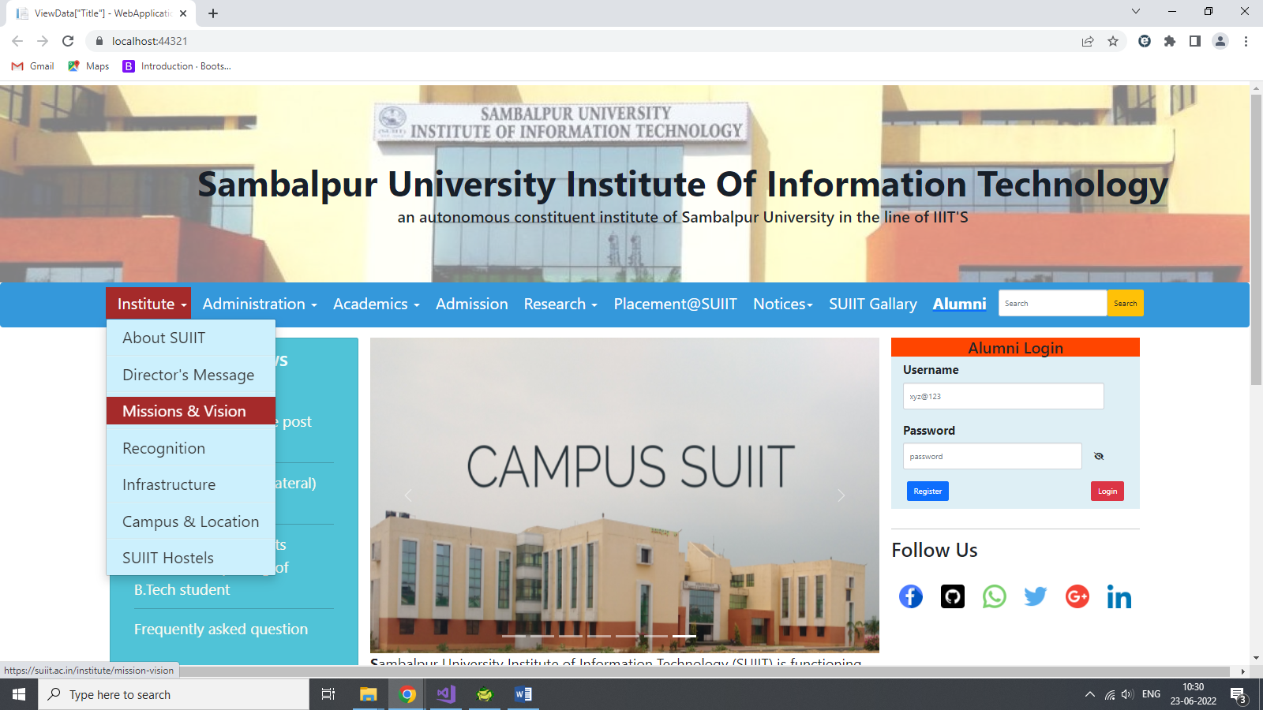

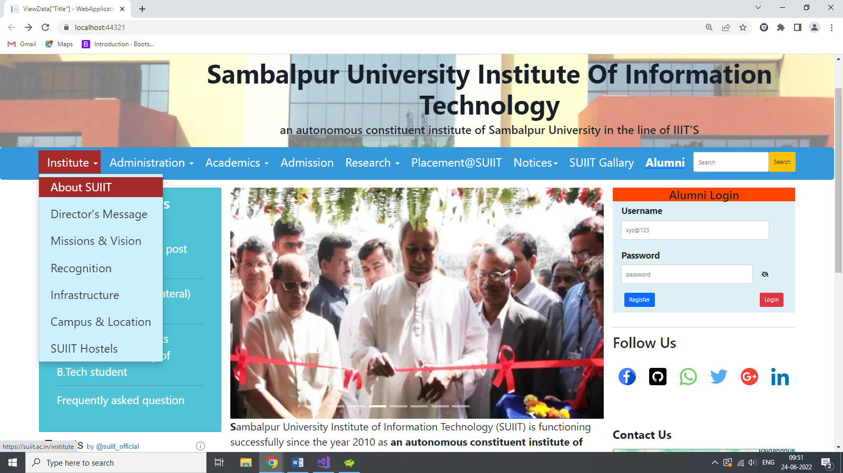



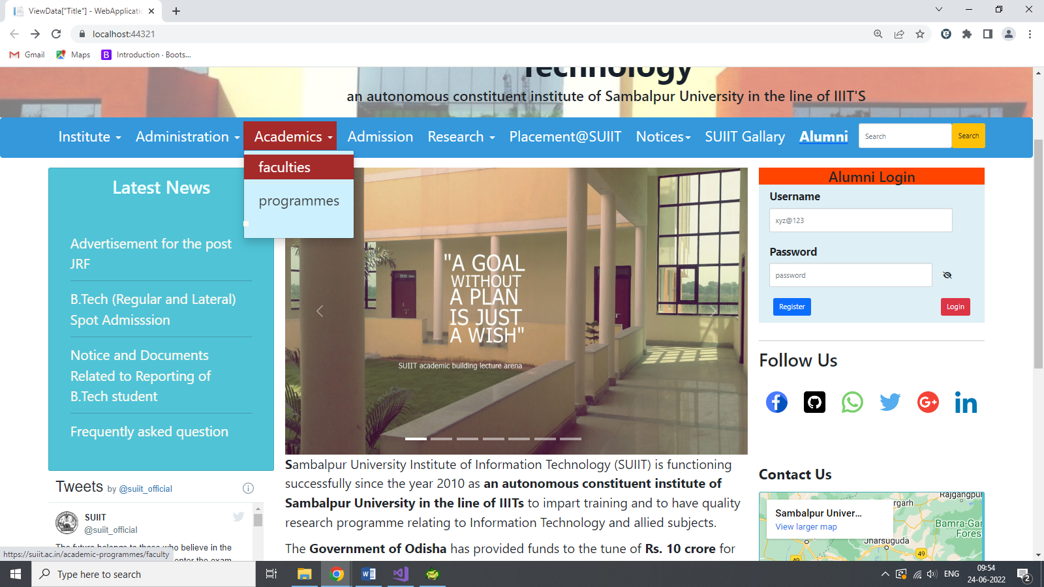

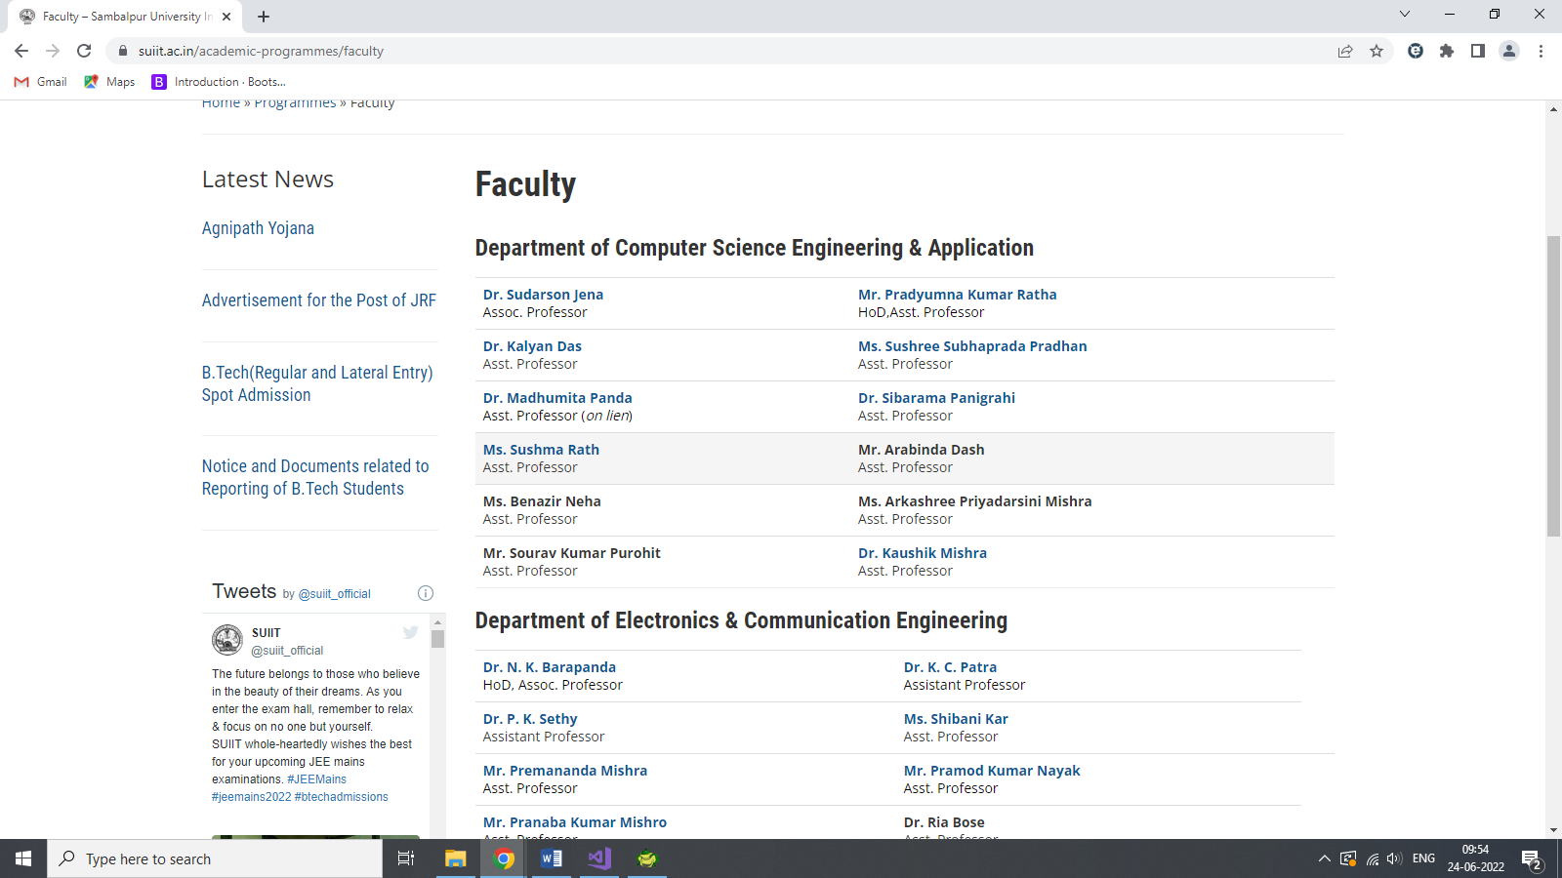

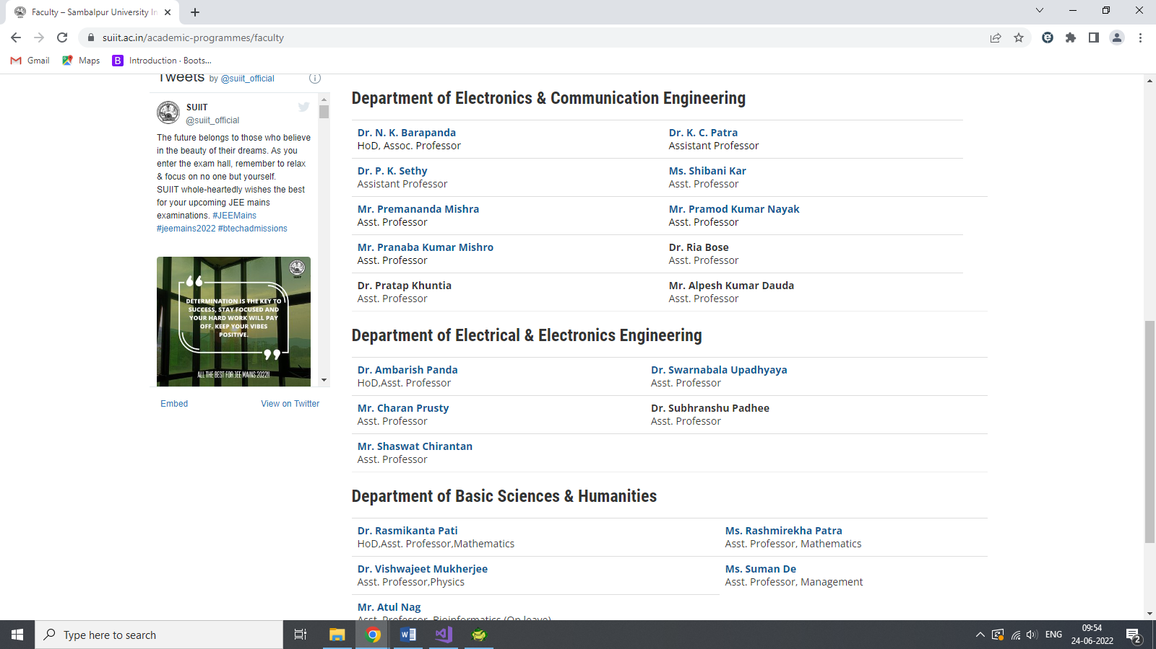

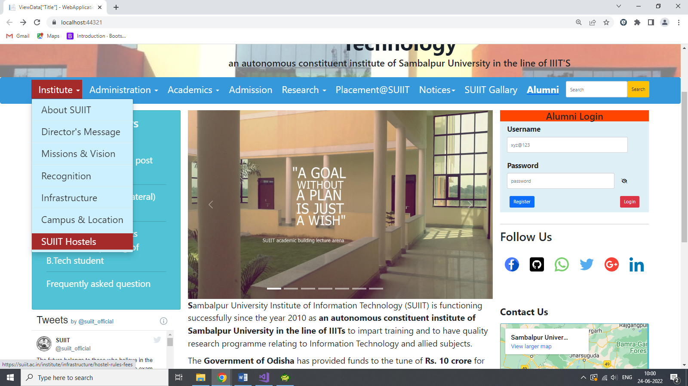

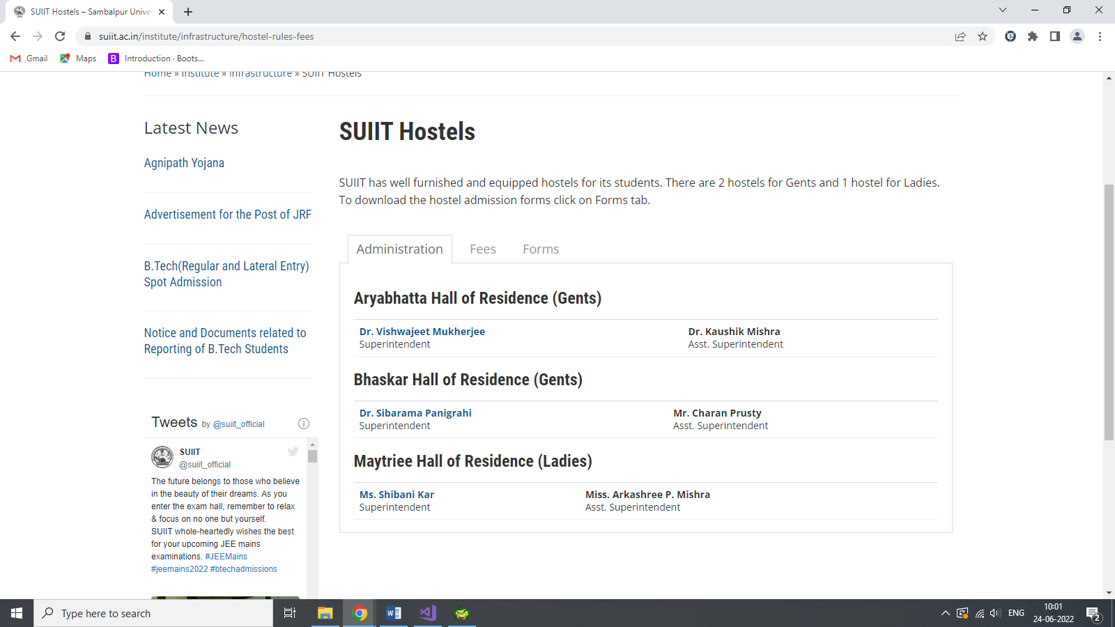

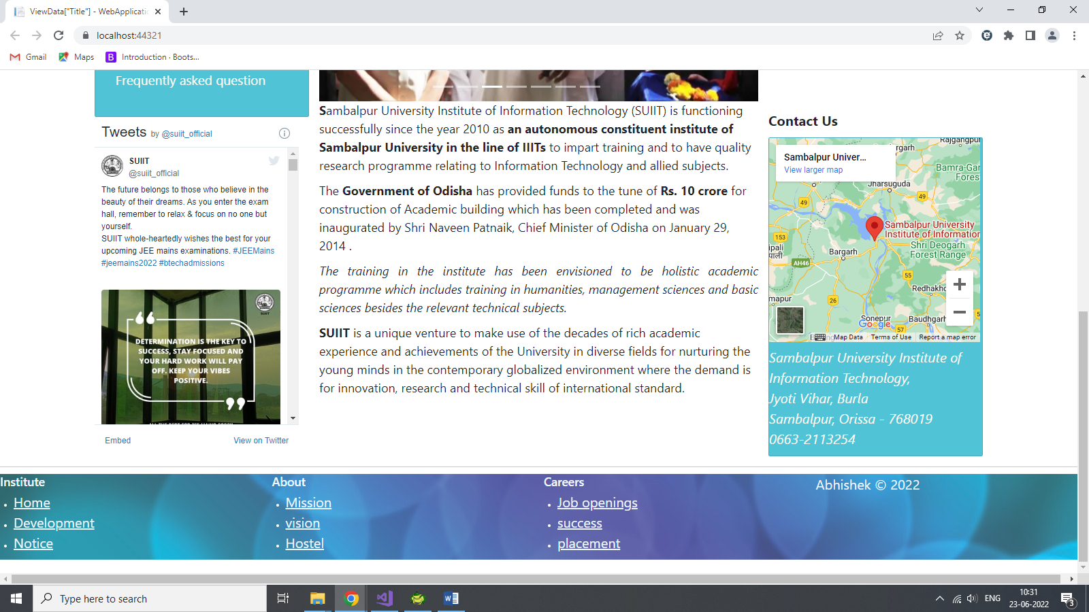

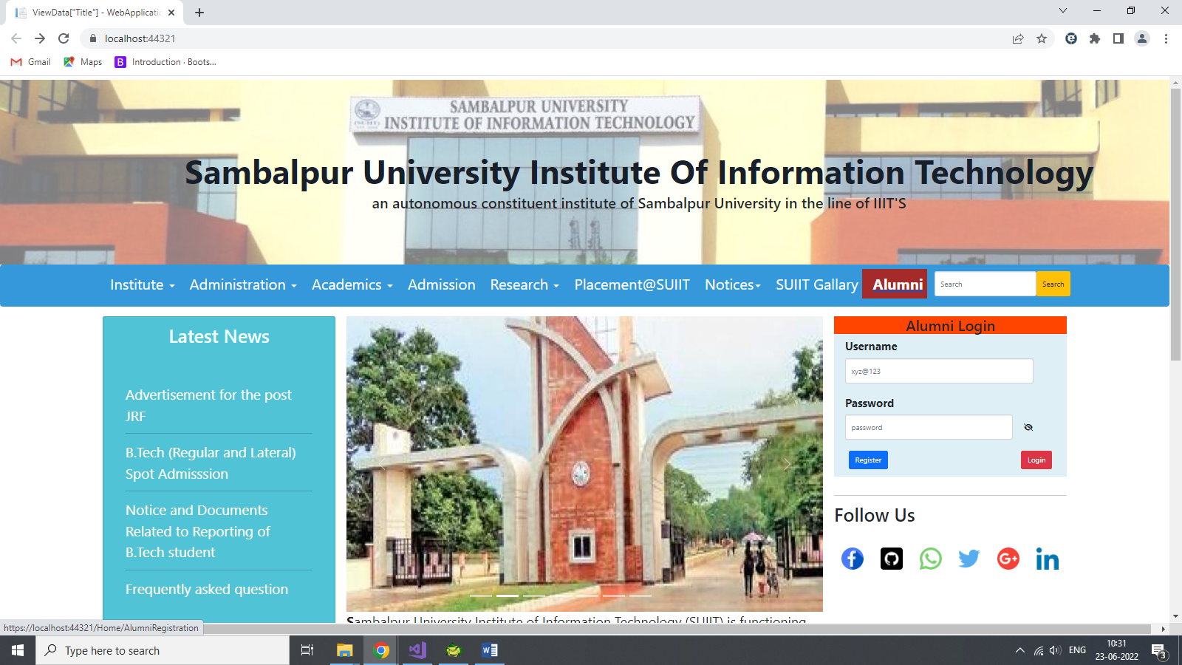

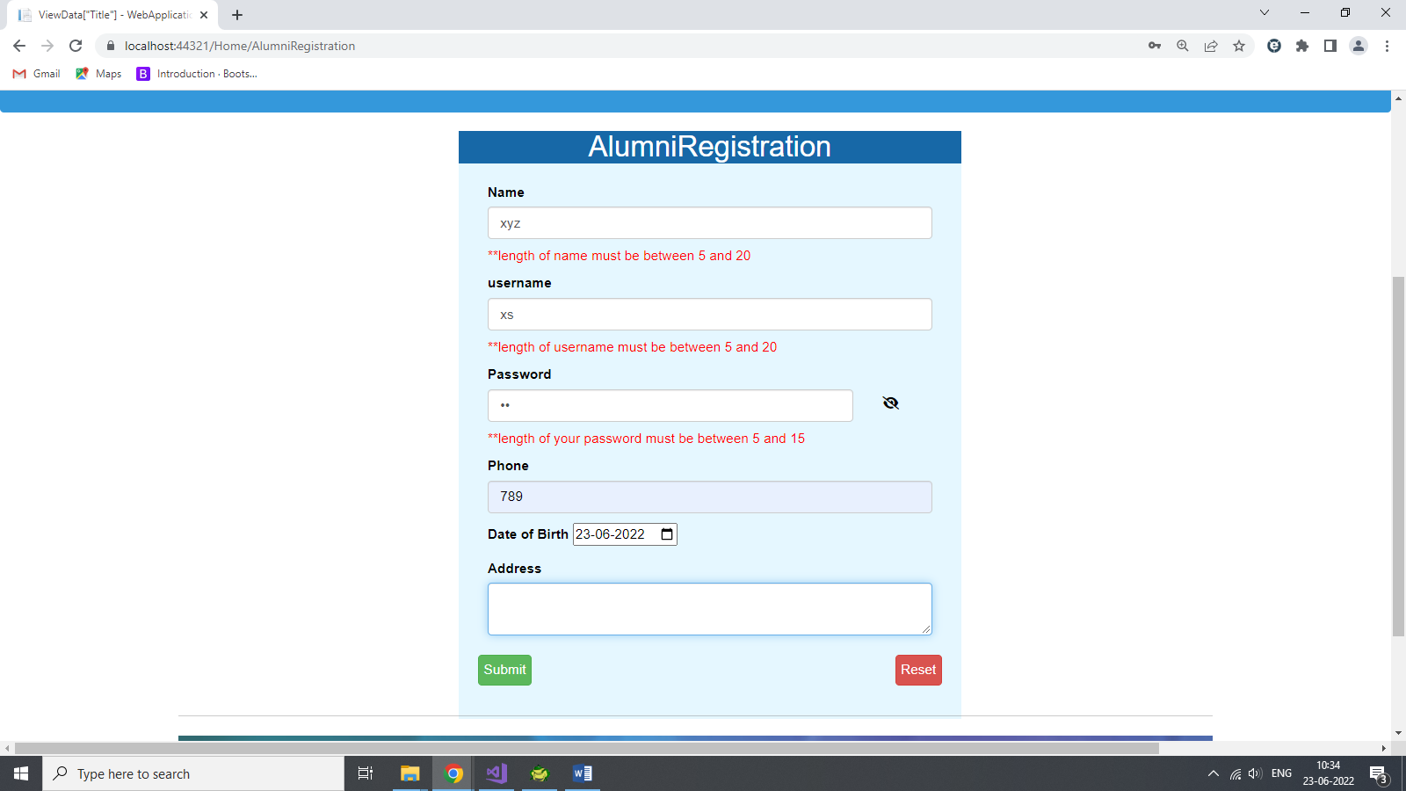

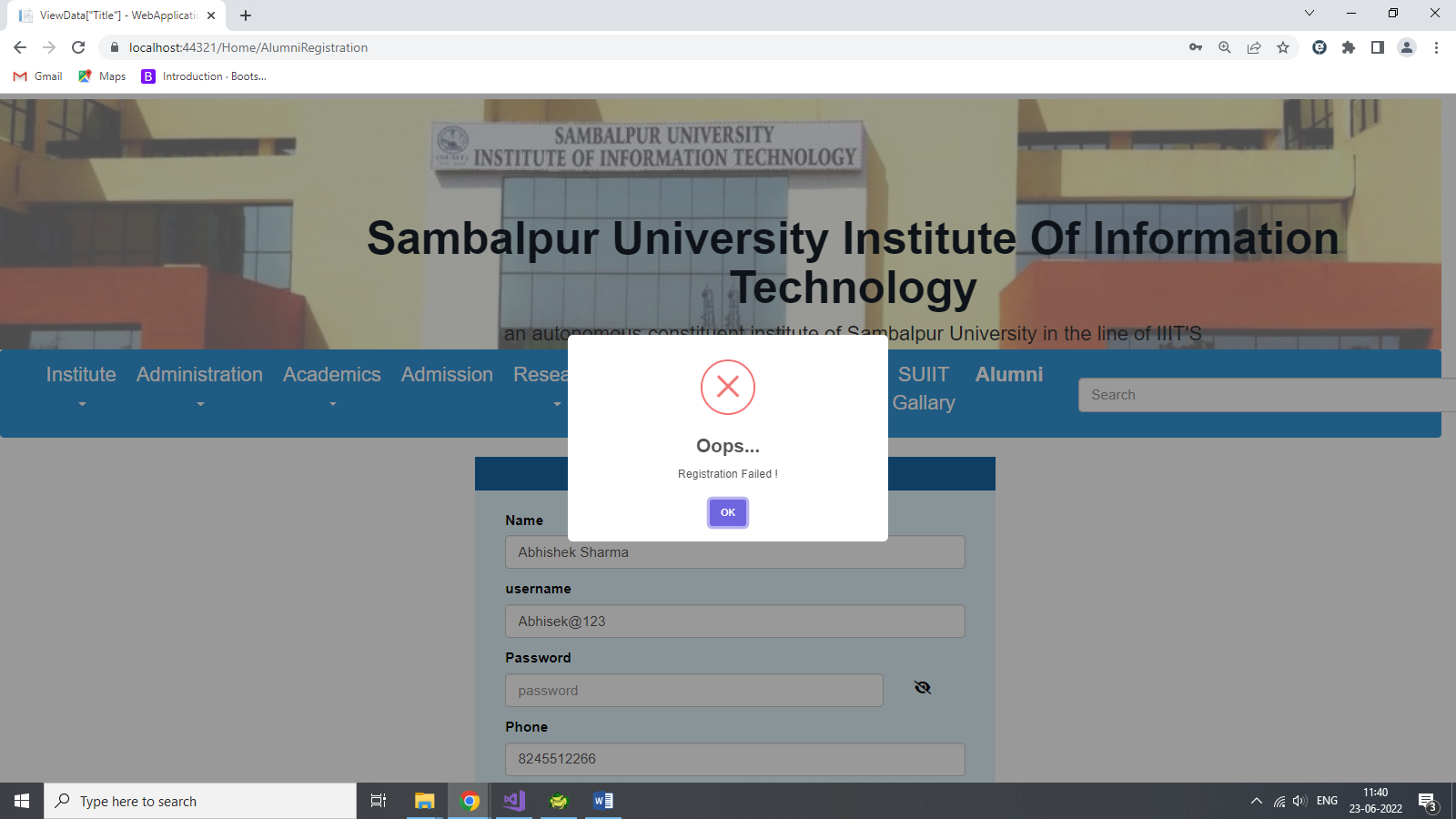

+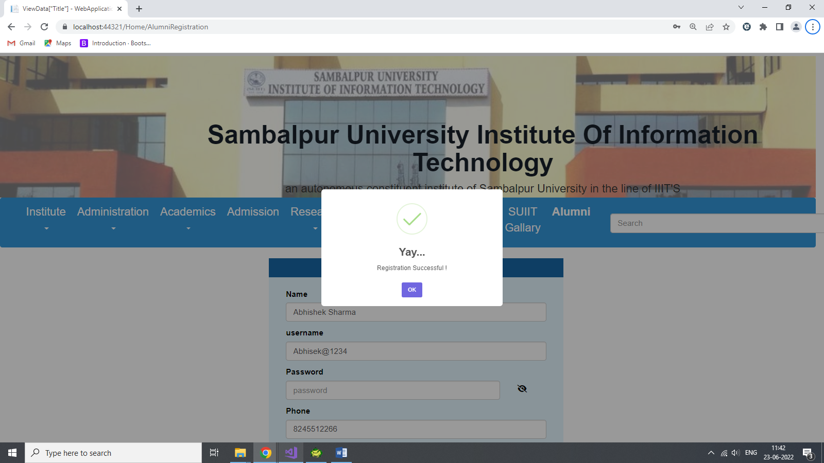

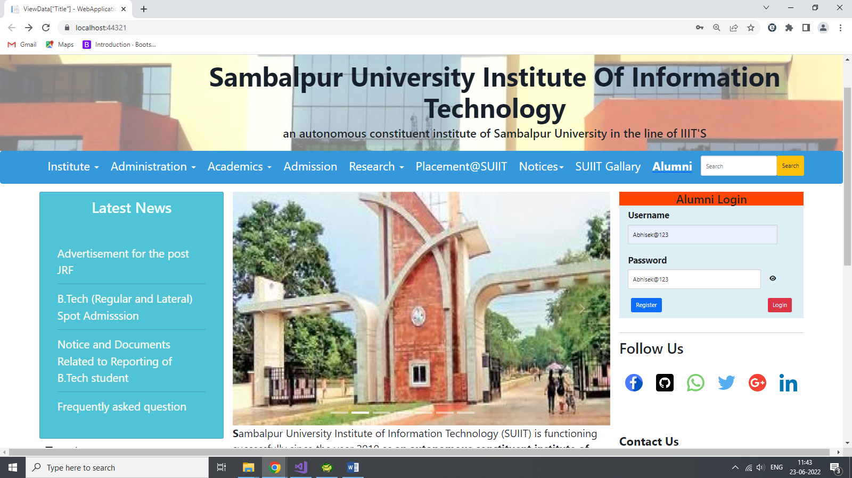

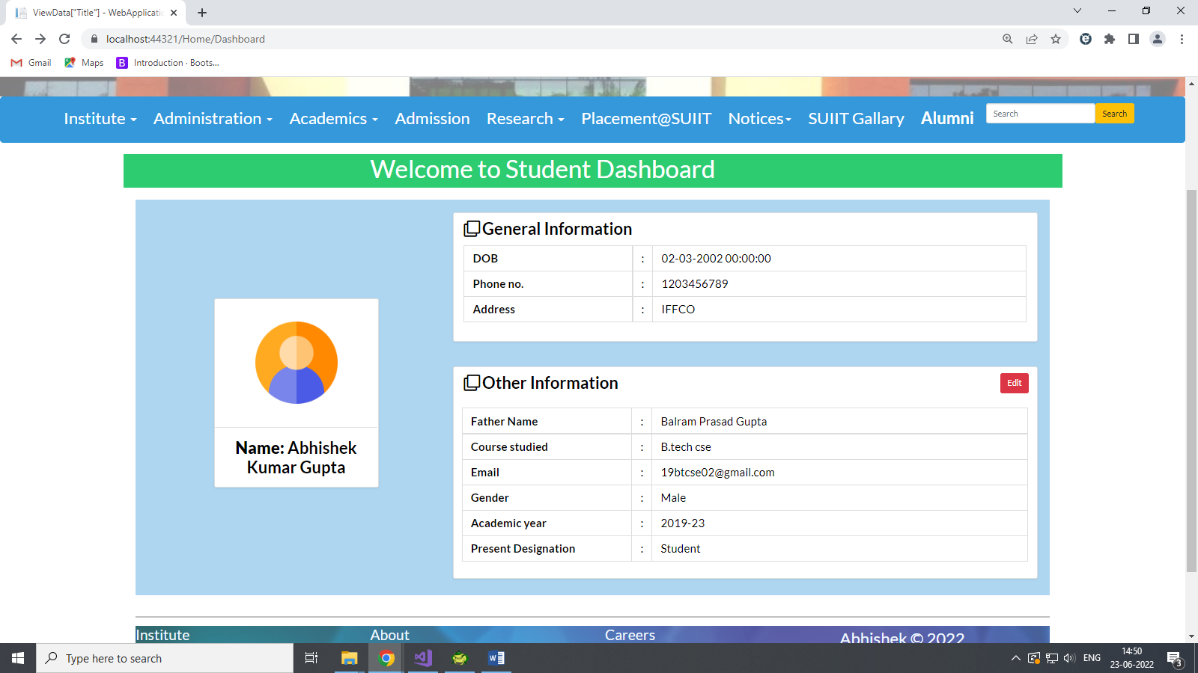

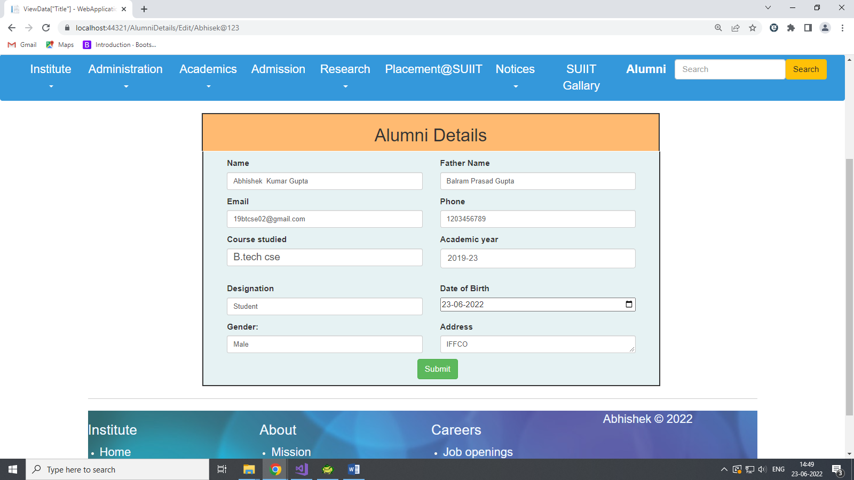

**Layout.cshtml**

<!DOCTYPE html>

<html>

<head>

<meta charset="utf-8" />

<meta name="viewport" content="width=device-width, initial-scale=1.0" />

<title>ViewData["Title"] - WebApplication1</title>

<link href="~/css/bootstrap.min.css" rel="stylesheet" />

<script src="~/js/bootstrap.min.js"></script>

<link rel="stylesheet" href="https://cdnjs.cloudflare.com/ajax/libs/font-awesome/6.1.1/css/all.min.css" integrity="sha512-KfkfwYDsLkIlwQp6LFnl8zNdLGxu9YAA1QvwINks4PhcElQSvqcyVLLD9aMhXd13uQjoXtEKNosOWaZqXgel0g==" crossorigin="anonymous" referrerpolicy="no-referrer" />

<style>

body {

padding: 0;

margin: 0;

font-family: 'Lato', sans-serif;

color: #000;

}

#nav_Container {

height: 320px;

margin-top: -45px;

}

.centered {

position: absolute;

top: 100px;

left: 250px;

}

.nav-link {

font-size: 20px;

margin-left: 10px;

}

#navbarNav {

justify-content: center;

text-align: center;

}

.dropdown-menu {

font-size: 15px;

}

li {

text-decoration:wavy;

color:floralwhite;

}

ul > li> :hover {

color: cadetblue;

background-color: brown;

}

.dropdown-menu .drop-item > a:hover {

background-color: brown;

color: white;

}

</style>

<environment include="Development">

<link rel="stylesheet" href="~/lib/bootstrap/dist/css/bootstrap.css" />

<link rel="stylesheet" href="~/css/site.css" />

</environment>

<environment exclude="Development">

<link rel="stylesheet" href="https://stackpath.bootstrapcdn.com/bootstrap/3.4.1/css/bootstrap.min.css"

asp-fallback-href="~/lib/bootstrap/dist/css/bootstrap.min.css"

asp-fallback-test-class="sr-only" asp-fallback-test-property="position" asp-fallback-test-value="absolute" />

<link rel="stylesheet" href="~/css/site.min.css" asp-append-version="true" />

</environment>

</head>

<body>

<div id="nav_Container">

<div id="clg-site" style="text-align:center;">

<img src="~/images/cropped-front.jpg" alt="" style="opacity:.5;height:250px;width:100%;" />

<div class="centered">

<h2 class="text-capitalize" style="font-size:45px; color:#17202A;"><b> Sambalpur University Institute of Information Technology</b></h2>

<h4 id="site-description" style="font-size:20px">an autonomous constituent institute of Sambalpur University in the line of IIIT'S</h4>

</div>

</div>

<div>

<nav class="navbar navbar-expand-lg navbar-dark btn-group-justified " style="background-color:#3498DB">

<div class="container-fluid">

@*<button class="navbar-toggler" type="button" data-bs-toggle="collapse" data-bs-target="#navbarNav" aria-controls="navbarNav" aria-expanded="false" aria-label="Toggle navigation">

<span class="navbar-toggler-icon"></span>

</button>*@

<div class="collapse navbar-collapse" id="navbarNav" style="text-align:center;">

<ul class="navbar-nav">

<li class="nav-item">

<div class="dropdown">

<a class="nav-link active" href="#" id="InstituteMenu" data-backdrop data-toggle="dropdown" style="text-decoration:none;">

Institute

<span class="caret"></span>

</a>

<ul class="dropdown-menu" aria-labelledby="InstituteMenu" ; style="font-size:20px; background-color:#CCF0FD; color:cornsilk ">

<li class="drop-item"><a href="https://suiit.ac.in/institute"" style="text-decoration:none; ">About SUIIT</a></li>

<li><hr class="dropdown-divider"></li>

<li class="drop-item"><a href="https://suiit.ac.in/institute/directors-message" style="text-decoration:none;">Director's Message</a></li>

<li><hr class="dropdown-divider"></li>

<li class="drop-item"><a href="https://suiit.ac.in/institute/mission-vision" style="text-decoration:none;">Missions & Vision</a></li>

<li><hr class="dropdown-divider"></li>

<li class="drop-item"><a href="https://suiit.ac.in/institute/rewards-recognition" style="text-decoration:none;">Recognition</a></li>

<li><hr class="dropdown-divider"></li>

<li class="drop-item"><a href="https://suiit.ac.in/institute/infrastructure" style="text-decoration:none;">Infrastructure</a></li>

<li><hr class="dropdown-divider"></li>

<li class="drop-item"><a href="https://suiit.ac.in/institute/campus-location" style="text-decoration:none;">Campus & Location</a></li>

<li><hr class="dropdown-divider"></li>

<li class="drop-item"><a href="https://suiit.ac.in/institute/infrastructure/hostel-rules-fees" style="text-decoration:none;">SUIIT Hostels</a></li>

</ul>

</div>

</li>

<li class="nav-item">

<div class="dropdown">

<a class="nav-link active" href="#" id="AdministrationsMenu" data-backdrop data-toggle="dropdown" style="text-decoration:wavy" role="button">

Administration

<span class="caret"></span>

</a>

<ul class="dropdown-menu" aria-labelledby="AdministrationsMenu" style="font-size:20px; background-color:#CCF0FD;">

<li class="drop-item"><a href="https://suiit.ac.in/home/co-ordinators/director" style="text-decoration:none">Director</a></li>

<li ><hr class="dropdown-divider"></li>

<li class="drop-item"><a href="https://suiit.ac.in/home/co-ordinators" style="text-decoration:none;">Executive authorities</a></li>

<li><hr class="dropdown-divider"></li>

<li class="drop-item"><a href="https://suiit.ac.in/home/adminstration" style="text-decoration:none;">Head of Department</a></li>

<li><hr class="dropdown-divider"></li>

<li class="drop-item"><a href="https://suiit.ac.in/home/heads-of-departments" style="text-decoration:none;">Recognition</a></li>

<li><hr class="dropdown-divider"></li>

<li class="drop-item"><a href"https://suiit.ac.in/home/holiday-list-2019" style="text-decoration:none;">Holidays lists</a></li>

<li><hr class="dropdown-divider"></li>

<li class="drop-item"><a href="https://suiit.ac.in/home/adminstration/forms" style="text-decoration:none;">Forms</a></li>

</ul>

</div>

</li>

<li class="nav-item">

<div class="dropdown">

<a class="nav-link active" href="https://suiit.ac.in/academic-programmes" id="AcademicsMenu" data-backdrop data-toggle="dropdown" ; style="text-decoration:wavy">

Academics

<span class="caret"></span>

</a>

<ul class="dropdown-menu" aria-labelledby="AcademicsMenu" style="font-size:20px; background-color:#CCF0FD;">

<li class="drop-item"><a href="https://suiit.ac.in/academic-programmes/faculty" style="text-decoration:none;">faculties </a></li>

<li><hr class="dropdown-divider"></li>

<li class="drop-item"><a href="#" style="text-decoration:none;">programmes</a></li>

<ul>

<li></li>

</ul>

</ul>

</div>

</li>

<li class="nav-item">

<div class="dropdown">

<a class="nav-link active" href="https://suiit.ac.in/admission" id="AdmissionMenu" data-backdrop data-toggle="dropdown"; style="text-decoration:wavy">

Admission

</a>

</div>

</li>

<li class="nav-item">

<div class="dropdown">

<a class="nav-link active" href="https://suiit.ac.in/research" id="AdmissionMenu" data-backdrop data-toggle="dropdown" ; style="text-decoration:wavy">

Research

<span class="caret"></span>

</a>

<ul class="dropdown-menu" aria-labelledby="ResearchMenu" style="font-size:20px; background-color:#CCF0FD;">

<li class="drop-item" ><a href="https://suiit.ac.in/research/publications" style="text-decoration:none;"> Publications</a></li>

<li><hr class="dropdown-divider"></li>

<li class="drop-item"><a href="https://suiit.ac.in/research-projects-and-patents" style="text-decoration:none;">project and patents</a></li>

</ul>

</div>

</li>

<li class="nav-item">

<div class="dropdown">

<a class="nav-link active" href="#" id="PlacementMenu" data-backdrop data-toggle="dropdown" ; style="text-decoration:wavy">

Placement@SUIIT

</a>

</div>

</li>

<li class="nav-item">

<div class="dropdown">

<a class="nav-link active" href="#" id="NoticeMenu" data-backdrop data-toggle="dropdown" ; style="text-decoration:wavy">

Notices<span class="caret"></span>

</a>

<ul class="dropdown-menu" aria-labelledby="NoticeMenu" style="font-size:20px; background-color:#CCF0FD;">

<li class="drop-item"><a href="https://suiit.ac.in/archives/category/notice" style="text-decoration:none;"> Notices</a></li>

<li><hr class="dropdown-divider"></li>

<li class="drop-item"><a href="https://suiit.ac.in/archives/category/seminars" style="text-decoration:none;">Lists</a></li>

<li><hr class="dropdown-divider"></li>

<li class="drop-item"><a href="https://suiit.ac.in/archives/category/ads" style="text-decoration:none;">Seminars</a></li>

<li><hr class="dropdown-divider"></li>

<li class="drop-item"><a href="https://suiit.ac.in/archives/category/jobs" style="text-decoration:none;">Job openings</a></li>

<li><hr class="dropdown-divider"></li>

<li class="drop-item"><a href="https://suiit.ac.in/rules-and-regulations" style="text-decoration:none;">Rules and Regulations</a></li>

</ul>

</div>

</li>

<li class="nav-item">

<div class="dropdown">

<a class="nav-link active" href="#" id="AcademicsMenu" data-backdrop data-toggle="dropdown" ; style="text-decoration:wavy">

SUIIT Gallary

</a>

</div>

</li>

<li class="nav-item">

<div class="dropdown">

<a asp-controller="Home" asp-action="AlumniRegistration">

<label class="nav-link active" style=" cursor:pointer; text-decoration:none; ">

Alumni

</label>

</a>

</div>

</li>

<li class="nav-item" style="padding-left:10px; padding-top:3px;">

<form class="d-flex" role="search">

<input class="form-control media-bottom" type="search" placeholder="Search" aria-label="Search">

<button class="btn bg-warning " type="submit">Search</button>

</form>

</li>

</ul>

</div>

</div>

</nav>

</div

</div>

<div class="container body-content">

@RenderBody()

<hr />

<footer style="background-image:url(/images/pexels-dana-tentis-370799.jpg);">

<div class="row justify-content-center">

<div class="col-sm-4 col-md-3 item">

<h3 style="color:aliceblue">Institute</h3>

<ul style="text-decoration:none;">

<li><a href="#" style="font-size:20px; color:aliceblue;">Home</a></li>

<li><a href="#" style="font-size:20px; color:aliceblue;">Development</a></li>

<li><a href="#" style="font-size:20px; color:aliceblue;">Notice</a></li>

</ul>

</div>

<div class="col-sm-4 col-md-3 item">

<h3 style="color:aliceblue">About</h3>

<ul>

<li><a href="#" style="font-size:20px; color:aliceblue;">Mission </a></li>

<li><a href="#" style="font-size:20px; color:aliceblue;">vision</a></li>

<li><a href="#" style="font-size:20px; color:aliceblue;">Hostel</a></li>

</ul>

</div>

<div class="col-sm-4 col-md-3 item">

<h3 style="color:aliceblue">Careers</h3>

<ul>

<li><a href="#" style="font-size:20px; color:aliceblue;">Job openings</a></li>

<li><a href="#" style="font-size:20px; color:aliceblue;">success</a></li>

<li><a href="#" style="font-size:20px; color:aliceblue;">placement</a></li>

</ul>

</div>

<div class="col-lg-3 item social">

<p class="copyright" style="font-size:20px; color:aliceblue;">Abhishek © 2022</p>

</div>

</div>

</footer>

</div>

<environment include="Development">

<script src="~/lib/jquery/dist/jquery.js"></script>

<script src="~/lib/bootstrap/dist/js/bootstrap.js"></script>

<script src="~/js/site.js" asp-append-version="true"></script>

</environment>

<environment exclude="Development">

<script src="https://ajax.aspnetcdn.com/ajax/jquery/jquery-3.3.1.min.js"

asp-fallback-src="~/lib/jquery/dist/jquery.min.js"

asp-fallback-test="window.jQuery"

crossorigin="anonymous"

integrity="sha384-tsQFqpEReu7ZLhBV2VZlAu7zcOV+rXbYlF2cqB8txI/8aZajjp4Bqd+V6D5IgvKT">

</script>

<script src="https://stackpath.bootstrapcdn.com/bootstrap/3.4.1/js/bootstrap.min.js"

asp-fallback-src="~/lib/bootstrap/dist/js/bootstrap.min.js"

asp-fallback-test="window.jQuery && window.jQuery.fn && window.jQuery.fn.modal"

crossorigin="anonymous"

integrity="sha384-aJ21OjlMXNL5UyIl/XNwTMqvzeRMZH2w8c5cRVpzpU8Y5bApTppSuUkhZXN0VxHd">

</script>

<script src="~/js/site.min.js" asp-append-version="true"></script>

</environment>

@RenderSection("Scripts", required: false)

</body>

</html>

**Index.cshtml**

@model AlumniRegMst

@{

ViewData["Title"] = "Home Page";

}

<link rel="stylesheet" href="https://cdnjs.cloudflare.com/ajax/libs/font-awesome/6.1.1/css/all.min.css" integrity="sha512-KfkfwYDsLkIlwQp6LFnl8zNdLGxu9YAA1QvwINks4PhcElQSvqcyVLLD9aMhXd13uQjoXtEKNosOWaZqXgel0g==" crossorigin="anonymous" referrerpolicy="no-referrer" />

<link href="~/css/bootstrap.min.css" rel="stylesheet" />

<script src="~/js/bootstrap.min.js"></script>

<script>

function Mypassword() {

var x = document.getElementById("Paswd");

var y = document.getElementById("eye1");

var z = document.getElementById("eye2");

if (x.type === 'password') {

x.type = "text";

y.style.display = "block";

z.style.display = "none";

}

else {

x.type = "password";

y.style.display = "none";

z.style.display = "block";

}

}

</script>

<style>

.card {

background-color: #50C3D7;

}

.inner-box {

width: 100%;

height: 80%;

background-position: center;

background-size: cover;

background-image: linear-gradient((rgba(0,0,100,0.8)rgba(0,0,100,0.8)), url(/images/curved11.jpg));

padding: 30px;

box-sizing: border-box;

backface-visibility: hidden;

}

#eye1 {

display: none;

}

#btnRegister {

margin-left:20px;

margin-bottom:10px;

}

#btnLogin {

float: right;

margin-right: 20px;

margin-bottom: 10px;

}

</style>

<div id="main_Container">

<div class="container1">

<div class="row">

<div class="col-lg-3">

<div class="card">

<h1 style="text-align:center; color:azure; margin-top:10px;">Latest News </h1> <br />

<div class="inner-box" style="width:auto; " ;>

<p style="font-size: 19px; color:floralwhite; font-family:'Segoe UI', Tahoma, Geneva, Verdana, sans-serif;" role="button">Advertisement for the post JRF </p>

<hr />

<p style="font-size: 19px; color:floralwhite" ; role="button">

B.Tech (Regular and Lateral) Spot Admisssion<br /> <hr />

</p>

<p style=" font;font-size: 19px; color:floralwhite;" role="button">

Notice and Documents Related to Reporting of B.Tech student <hr />

</p>

<p style="font-size: 19px; color:floralwhite;" role="button">

Frequently asked question

</p>

</div>

</div>

<div>

<div id="block-11" class="widget clearfix widget_block">

<a class="twitter-timeline" data-width="auto" data-height="500" data-dnt="true" href="https://twitter.com/suiit_official">Tweets by SUIIT</a>

<script async src="https://platform.twitter.com/widgets.js" charset="utf-8"></script>

</div>

</div>

</div>

<div class="col-lg-6">

<div>

<div id="carouselExampleIndicators" class="carousel slide" data-bs-ride="carousel">

<div class="carousel-indicators">

<button type="button" data-bs-target="#carouselExampleIndicators" data-bs-slide-to="0" class="active" aria-current="true" aria-label="Slide 1"></button>

<button type="button" data-bs-target="#carouselExampleIndicators" data-bs-slide-to="1" aria-label="Slide 2"></button>

<button type="button" data-bs-target="#carouselExampleIndicators" data-bs-slide-to="2" aria-label="Slide 3"></button>

<button type="button" data-bs-target="#carouselExampleIndicators" data-bs-slide-to="3" aria-label="Slide 4"></button>

<button type="button" data-bs-target="#carouselExampleIndicators" data-bs-slide-to="4" aria-label="Slide 5"></button>

<button type="button" data-bs-target="#carouselExampleIndicators" data-bs-slide-to="5" aria-label="Slide 6"></button>

<button type="button" data-bs-target="#carouselExampleIndicators" data-bs-slide-to="6" aria-label="Slide 7"></button>

</div>

<div class="carousel-inner">

<div class="carousel-item active">

<img src="~/images/9.jpg" height="400" class="d-block w-100" alt="...">

</div>

<div class="carousel-item">

<img src="~/images/ec7afeaad4893733e04704f869dc4980.jpg" height="400" class="d-block w-100" alt="...">

</div>

<div class="carousel-item">

<img src="~/images/inaguration3 .jpg" height="400" class="d-block w-100" alt="...">

</div>

<div class="carousel-item">

<img src="~/images/qwertyj.webp" height="400" class="d-block w-100" alt="...">

</div>

<div class="carousel-item">

<img src="~/images/quotes-.webp" height="400" class="d-block w-100" alt="...">

</div>

<div class="carousel-item">

<img src="~/images/just-start-motivational-phrase-on-laptop-vwfahk03yiajqbg0.jpg" height="400" class="d-block w-100" alt="...">

</div>

<div class="carousel-item">

<img src="~/images/unnamed.png" height="400" class="d-block w-100" alt="...">

</div>

</div>

<button class="carousel-control-prev" type="button" data-bs-target="#carouselExampleIndicators" data-bs-slide="prev">

<span class="carousel-control-prev-icon" aria-hidden="true"></span>

<span class="visually-hidden">Previous</span>

</button>

<button class="carousel-control-next" type="button" data-bs-target="#carouselExampleIndicators" data-bs-slide="next">

<span class="carousel-control-next-icon" aria-hidden="true"></span>

<span class="visually-hidden">Next</span>

</button>

</div>

</div>

<div>

<p style="font-size: 18px">

<span><b>S</b>ambalpur University Institute of Information Technology (SUIIT) is functioning successfully since the year 2010&nbsp;as </span><strong style="line-height: 1.5;">an autonomous constituent institute of Sambalpur University in the line of IIITs</strong><span style="line-height: 1.5;"> to impart training and to have quality research programme relating to Information Technology and allied subjects.</span>

</p>

<p style="font-size: 18px">

The <strong>Government of Odisha</strong> has provided funds to the tune of <strong>Rs. 10 crore</strong> for construction of Academic building which has been completed and was inaugurated by Shri Naveen Patnaik, Chief Minister of Odisha on January 29, 2014&nbsp;.

<p style="text-align: justify; font-style: italic; font-size:18px;">The training in the institute has been envisioned to be holistic academic programme which includes training in humanities, management sciences and basic sciences besides the relevant technical subjects.</p>

<p style="font-size: 18px"> <b>SUIIT</b> is a unique venture to make use of the decades of rich academic experience and achievements of the University in diverse fields for nurturing the young minds in the contemporary globalized environment where the demand is for innovation, research and technical skill of international standard.</p>

</div>

</div>

<div class="col-lg-3">

<div class="column column-narrow column-last">

<form asp-controller="Home" asp-action="Dashboard" style="background-color:#DEEFF5;">

<h2 style="text-align:center; background-color:orangered;">Alumni Login</h2>

<div class="form-group" style="margin-right:45px; margin-left:15px;">

<label for="username" class="form-label" style="font-size:15px;">Username </label>

<input type="text" class="form-control" required id="txtUsername" aria-describedby="username" placeholder="xyz@123" asp-for="@Model.Username" />

</div>

<div class="form-group" style="margin-right:25px; margin-left:15px; ">

<label for="Name" class="form-label" style="font-size:15px;">Password </label>

<div class="row">

<div class="col-lg-10">

<input type="password" class="form-control" id="Paswd" required placeholder="password" asp-for="@Model.Password" />

</div>

<div class="col-lg-2" style="margin-top:10px">

<span class="eye" onclick="Mypassword()">

<i id="eye1" class="fa-solid fa-eye"></i>

<i id="eye2" class="fa-solid fa-eye-slash"></i>

</span>

</div>

</div>

</div>

<div>

<input type="submit" value="Login" class="btn btn-danger" id="btnLogin" />

<input type="button" value="Register" class="btn btn-primary" id="btnRegister" />

</div>

</form>

</div>

<div id="block-4" class="widget clearfix widget_block"><br /><hr />

<h1>Follow Us</h1>

<br />

<img src="~/images/facebook.png" alt="Alternate Text" height="30" ; width="30" btn-floating; href="#!" role="button" style="margin:10px;" />

<img src="~/images/github.png" alt="Alternate Text" height="30" width="30" role="button" style="margin:10px;" />

<img src="~/images/whatsapp.png" alt="Alternate Text" height="30" width="30" role="button" style="margin:10px;" />

<img src="~/images/twitter.png" alt="Alternate Text" height="30" width="30" role="button" style="margin:10px;"/>

<img src="~/images/google-plus.png" alt="Alternate Text" height="30" width="30" role="button" style="margin:10px;" />

<img src="~/images/linkedin.png" alt="Linked In" height="30" width="30" role="button" style="margin:10px;" />

<br /><br /><br /><br /> <br />

</div>

<div class="dow">

<div id="block-7" class="widget clearfix widget_block">

<p id="contact-us" style="font-size:20px;"><b>Contact Us</b></p>

<div class="card">

<address style="font-style: italic; color:floralwhite; font-size:20px">

<iframe src="https://www.google.com/maps/embed?pb=!1m18!1m12!1m3!1d950432.2217515922!2d82.76419533125!3d21.48319189999999!2m3!1f0!2f0!3f0!3m2!1i1024!2i768!4f13.1!3m3!1m2!1s0x3a213c368309af57%3A0xdcd4d19c95624841!2sSambalpur%20University%20Institute%20of%20Information%20Technology%20(SUIIT)%2C%20Burla!5e0!3m2!1sen!2sin!4v1654923874331!5m2!1sen!2sin" width="310" height="300" style="border:0;" allowfullscreen="" loading="lazy" referrerpolicy="no-referrer-when-downgrade"></iframe>

Sambalpur University Institute of Information Technology,<br>

Jyoti Vihar, Burla<br>

Sambalpur, Orissa - 768019<br>

0663-2113254

</address>

</div>

</div>

</div>

</div>

</div>

</div>

</div>

**AlumniRegistration.cshtml Page**

@model AlumniRegMst

@{

ViewData["Title"] = "AlumniRegistration";

}

<link rel="stylesheet" href="//code.jquery.com/ui/1.12.1/themes/base/jquery-ui.css">

<link rel="stylesheet" href="https://cdnjs.cloudflare.com/ajax/libs/font-awesome/6.1.1/css/all.min.css" integrity="sha512-KfkfwYDsLkIlwQp6LFnl8zNdLGxu9YAA1QvwINks4PhcElQSvqcyVLLD9aMhXd13uQjoXtEKNosOWaZqXgel0g==" crossorigin="anonymous" referrerpolicy="no-referrer" />

<script src="https://code.jquery.com/jquery-3.6.0.js" integrity="sha256-H+K7U5CnXl1h5ywQfKtSj8PCmoN9aaq30gDh27Xc0jk=" crossorigin="anonymous"></script>

<script src="//cdn.jsdelivr.net/npm/sweetalert2@11"></script>

<script>

function MyFunction() {

var x = document.getElementById("Password1");

var y = document.getElementById("hide1");

var z = document.getElementById("hide2");

if (x.type === 'password') {

x.type = "text";

y.style.display = "block";

z.style.display = "none";

}

else {

x.type = "password";

y.style.display = "none";

z.style.display = "block";

}

}

$(function () {

var msg = '@ViewData["result"]';

if (msg == "A") {

Swal.fire({

icon: 'success',

title: 'Yay...',

text: 'Registration Successful !'

})

}

else if (msg == "B") {

Swal.fire({

icon: 'error',

title: 'Oops...',

text: 'Registration Failed !'

})

}

});

$(document).ready(function () {

debugger;

var currDate = new Date();

var year = currDate.getFullYear();

var month = currDate.getMonth() + 1;

var date = currDate.getDate();

if (month < 10) {

month = "0" + month;

}

if (date < 10) {

date = "0" + date;

}

var today = year + "-" + month + "-" + date;

$('#clDate').val(today);

$('#clDate').attr("max", today);

// Validate name

$("#namecheck").hide();

let nameError = true;

$("#txtName").keyup(function () {

validatename();

});

function validatename() {

let nameValue = $("#txtName").val();

if (nameValue.length == "") {

$("#namecheck").show();

nameError = false;

return false;

}

else if (nameValue.length < 5 || nameValue.length > 20) {

$("#namecheck").show();

$("#namecheck").html("**length of name must be between 5 and 20");

nameError = false;

return false;

} else {

$("#namecheck").hide();

}

}

$("#usercheck").hide();

let usernameError = true;

$("#txtUsername").keyup(function () {

validateUsername();

});

function validateUsername() {

let usernameValue = $("#txtUsername").val();

if (usernameValue.length == "") {

$("#usercheck").show();

usernameError = false;

return false;

}

else if (usernameValue.length < 5 || usernameValue.length > 20) {

$("#usercheck").show();

$("#usercheck").html("**length of username must be between 5 and 20");

usernameError = false;

return false;

}

else {

$("#usercheck").hide();

}

}

// Validate Password

$("#passcheck").hide();

let passwordError = true;

$("#Password1").keyup(function () {

validatePassword();

});

function validatePassword() {

let passwordValue = $("#Password1").val();

if (passwordValue.length == "") {

$("#passcheck").show();

passwordError = false;

return false;

}

if (passwordValue.length < 5 || passwordValue.length > 15) {

$("#passcheck").show();

$("#passcheck").html(

"**length of your password must be between 5 and 15"

);

$("#passcheck").css("color", "red");

passwordError = false;

return false;

} else {

$("#passcheck").hide();

}

}

});

</script>

<style>

#navbarNav {

justify-content: center;

text-align: center;

}

#Alumniform {

width: auto;

align-content: center;

align-items: center;

}

.col-lg-6 {

margin-top: 10px;

}

form {

margin: 20px;

width: 600px;

}

#btnSubmit {

float: left;

padding: 5px;

margin-bottom:10px;

margin-top:10px;

}

input[type=reset] {

float: right;

padding: 5px;

margin-top:10px;

margin-bottom: 10px;

}

.container {

position: center;

width: 1100px;

}

.col-lg-6 {

position: center;

margin-top: 10px;

}

form i {

cursor: pointer;

line-height: normal

}

.eye {

display: inline;

position: absolute;

margin-top: 5px;

width: 100%;

height: 100%;

}

#AlumniCard {

color: black;

background-color: #E5F7FF;

height: 102%;

}

#hide1 {

display: none;

}

.form-group {

margin: 10px;

}

</style>

<div class="container" style="margin-top:15px;">

<div class="row">

<div class="col-lg-3"></div>

<div class="col-lg-6">

<div id="AlumniCard">

<div style="text-align:center; background-color:#1768A7; color:white; position:center;">

<h2 style="margin-top:13px;">AlumniRegistration</h2>

</div>

<div>

<**form** **asp-controller**="Home" **asp-action**="AlumniRegistration" id="Alumniform">

<div class="form-group">

<label for="Name" class="form-label">Name </label>

<**input** **type**="text" class="form-control" required id="txtName" **name**="name" aria-describedby="name" placeholder="Fullname" **asp-for**="@Model.Name">

<h5 id="namecheck" style="color: red;">

**name is missing

</h5>

</div>

<div class="form-group">

<label for="username" class="form-label">username </label>

<**input** **type**="text" class="form-control" required id="txtUsername" aria-describedby="username" placeholder="xyz@123" **asp-for**="@Model.Username">

<h5 id="usercheck" style="color: red;">

**Username is missing

</h5>

</div>

<div class="form-group">

<label for="Name" class="form-label">Password </label>

<div class="row">

<div class="col-lg-10">

<**input** **type**="password" class="form-control" id="Password1" required placeholder="password" **name**="password" **asp-for**="@Model.Password" />

</div>

<div class="col-lg-2">

<span class="eye" onclick="MyFunction()">

<i id="hide1" class="fa-solid fa-eye"></i>

<i id="hide2" class="fa-solid fa-eye-slash"></i>

</span>

</div>

</div>

<h5 id="passcheck" style="color: red;">

**Please Fill the password

</h5>

</div>

<div class="form-group">

<label for="Phone" class="form-label">Phone</label>

<**input** **type**="number" class="form-control" required id="phone" placeholder="0123456789" **asp-for**="@Model.PhoneNo">

</div>

<div class="form-group">

<label for="clDate" class="form-label">Date of Birth</label>

<**input** **type**="date" id="clDate" aria-describedby="dateofbirth" **asp-for**="@Model.Birthdate" />

</div>

<div class="form-group">

<label for="TxtAddress" class="form-label">Address </label>

<**textarea** class="form-control" id="TxtAddress" required aria-describedby="Address" **asp-for**="@Model.Address"></**textarea**>

</div>

<div>

<input type="submit" value="Submit" class="btn btn-success" id="submitbtn" />

<input type="reset" class="btn btn-danger" />

</div>

</**form**>

</div>

</div>

</div>

</div>

</div>

**DashBoard.cshtml page**

@model CommonClass

@{

ViewData["Title"] = "Dashboard";

}

<link href="https://fonts.googleapis.com/css?family=Lato:300,400,700,900&display=swap" rel="stylesheet">

<link rel='stylesheet' href='https://cdnjs.cloudflare.com/ajax/libs/twitter-bootstrap/4.1.3/css/bootstrap.min.css'>

<link rel='stylesheet' href='https://cdnjs.cloudflare.com/ajax/libs/font-awesome/5.12.1/css/all.min.css'>

<style>

body {

padding: 0;

margin: 0;

font-family: 'Lato', sans-serif;

color: #000;

}

.student-profile .card h3 {

font-size: 20px;

font-weight: 700;

}

.student-profile .card p {

font-size: 16px;

color: #000;

}

.student-profile .table th,

.student-profile .table td {

font-size: 14px;

padding: 5px 10px;

color: #000;

}

#btnEdit {

float:right;

margin-left:30px;

}

</style>

<script>

</script>

<div class="row" style="background-color:#2ECC71;">

<div class="col-lg-3"></div>

<div class="col-lg-6" >

<h2 style="color:white; font-size:30px"> Welcome to Student Dashboard</h2>

</div>

</div>

<div class="student-profile py-4">

<div class="container" style="background-color:#AED6F1;">

<div class="row">

<div class="col-lg-4">

<div class="card shadow-sm" style="height:230px; width:200px; margin-left:80px; margin-top:120px;">

<div class="card-header bg-transparent text-center">

<img class="profile_img" src="~/images/user (1).png" style="width:100px; margin:20px 20px 20px 20px;" alt="student dp">

</div>

<div class="card-body" style="height:auto; width:auto;">

<h3 style="text-align:center;"><b>Name:</b> @Html.DisplayFor(Model => Model.AlumniDtlsObj.Fullname) </h3>

</div>

</div>

</div>

<div class="col-lg-8">

<div class="card shadow-sm" style="margin-top:15px;">

<div class="card-header bg-transparent border-0">

<h3 class="mb-0"><i class="far fa-clone pr-1"></i>General Information</h3>

</div>

<div class="card-body pt-0">

<table class="table table-bordered">

<tr>

<th width="30%">DOB</th>

<td width="2%">:</td>

<td> @Html.DisplayFor(Model => Model.AlumniDtlsObj.BirthDate)</td>

</tr>

<tr>

<th width="30%">Phone no.</th>

<td width="2%">:</td>

<td> @Html.DisplayFor(Model => Model.AlumniDtlsObj.PhoneNo)</td>

</tr>

<tr>

<th width="30%">Address</th>

<td width="2%">:</td>

<td> @Html.DisplayFor(Model => Model.AlumniDtlsObj.Address)</td>

</tr>

</table>

</div>

</div>

<div class="card shadow-sm" style="margin-top:30px; margin-bottom:20px;" >

<div class="card-header bg-transparent border-0" >

<div class="row">

<div class="col-lg-9">

<h3 class="mb-0"><i class="far fa-clone pr-1"></i>Other Information</h3>

</div>

<div class="col-lg-2">

</div>

<div class="col-lg-1">

<div class="card-body pt-0" style="margin-left:20px;">

<**a** **asp-controller**="AlumniDetails" **asp-action**="Edit" **asp-route-id**="@Model.AlumniRegMstObj.Username">

<input type="submit" value="Edit" class="btn btn-danger" id="btnEdit" />

</**a**>

</div>

</div>

</div>

</div>

<div style="padding:10px;">

<table class="table table-bordered">

<tr>

<th width="30%">Father Name</th>

<td width="2%">:</td>

<td>@Model.AlumniDtlsObj.FatherName</td>

</tr>

<tr>

<th width="30%">Course studied</th>

<td width="2%">:</td>

<td>@Model.AlumniDtlsObj.Course</td>

</tr>

<tr>

<th width="30%">Email</th>

<td width="2%">:</td>

<td>@Model.AlumniDtlsObj.Email</td>

</tr>

<tr>

<th width="30%">Gender</th>

<td width="2%">:</td>

<td>@Model.AlumniDtlsObj.Gender</td>

</tr>

<tr>

<th width="30%">Academic year</th>

<td width="2%">:</td>

<td>@Model.AlumniDtlsObj.Academic</td>

</tr>

<tr>

<th width="30%">Present Designation</th>

<td width="2%">:</td>

<td>@Model.AlumniDtlsObj.Designation</td>

</tr>

</table>

</div>

</div>

</div>

</div>

</div>

</div>

@*@Html.DisplayFor(Modelname => @Model.Name)

@Html.DisplayFor(ModelPhone => @Model.PhoneNo)

@Html.DisplayFor(ModelBirthdate => @Model.Birthdate)

@Html.DisplayFor(ModelAddress => @Model.Address)

</div>

</div>

</div>

</div>*@

Edit.cshtml Page

@model CommonClass

@{

ViewData["Title"] = "Edit";

}

<script src="~/js/jquery-3.6.0.min.js"></script>

<script type="text/javascript">

$(document).ready(function () {

debugger;

var currDate = new Date();

var year = currDate.getFullYear();

var month = currDate.getMonth() + 1;

var date = currDate.getDate();

if (month < 10) {

month = "0" + month;

}

if (date < 10) {

date = "0" + date;

}

var today = year + "-" + month + "-" + date;

$('#crDate').val(today);

$('#crDate').attr('max', today);

});

</script>

<div class="panel-body" style="height:20px;"></div>

<div class="row">

<div class="col-lg-2"></div>

<div class="col-lg-8" style="text-align:center; margin-left:14px; border-color:black; border-left:solid; border-right:solid; border-top:solid; border-width:2px; background-color:#FFBA71">

<h2>Alumni Details</h2>

</div>

<div class="col-lg-2"></div>

</div>

<div class="container">

<**form** **asp-controller**="AlumniDetails" **asp-action**="Edit">

<div class="row">

<div class="col-lg-2"></div>

<div class="col-lg-8" style="border-color:black; border-left:solid; border-right:solid; border-bottom:solid; border-width:2px; background-color:#E6F2F3;">

<div class="row" style="margin:10px;">

<div class="col-lg-6">

<div class="form-group-sm">

<label for="Name" class="form-label">Name </label>

<**input** **type**="text" class="form-control" id="txtName" aria-describedby="name" **asp-for**="@Model.AlumniDtlsObj.Fullname" />

</div>

</div>

<div class="col-lg-6">

<div class="form-group-sm">

<label for="Fathername" class="form-label">Father Name</label>

<**input** **type**="text" class="form-control" id="txtFTname" aria-describedby="FTname" **asp-for**="@Model.AlumniDtlsObj.FatherName">

</div>

</div>

</div>

<div class="row" style="margin:10px;">

<div class="col-lg-6">

<div class="form-group-sm">

<label for="Email" class="form-label">Email</label>

<**input** **type**="email" class="form-control" id="Email" **asp-for**="@Model.AlumniDtlsObj.Email" />

</div>

</div>

<div class="col-lg-6">

<div class="form-group-sm">

<label for="Phone" class="form-label">Phone</label>

<**input** **type**="number" class="form-control" id="phone" **asp-for**="@Model.AlumniDtlsObj.PhoneNo" />

</div>

</div>

</div>

<div class="row" style="margin:10px;">

<div class="col-lg-6">

<div class="form-group-sm">

<label for="course" class="form-label">Course studied </label>

<**input** **type**="text" class="form-control" id="txtCourse" style="font-size:17px;" **asp-for**="@Model.AlumniDtlsObj.Course">

</div>

</div>

<div class="col-lg-6">

<div class="form-group">

<label for="Academic" class="form-label">Academic year </label>

<**input** **type**="datetime" class="form-control" required id="txtCourse" aria-describedby="Course" **asp-for**="@Model.AlumniDtlsObj.Academic">

</div>

</div>

</div>

<div class="row" style="margin:10px;">

<div class="col-lg-6">

<div class="fform-group-sm">

<div class="form-group-sm">

<label for="Designation" class="form-label">Designation</label>

<**input** **type**="text" class="form-control" id="Designation" aria-describedby="Designation" **asp-for**="@Model.AlumniDtlsObj.Designation">

</div>

</div>

</div>

<div class="col-lg-6">

<div class="form-group-sm">

<label for="crDate" class="form-label">Date of Birth</label><br />

<**input** **type**="date" id="crDate" aria-describedby="dateofbirth" style="width:100%" **asp-for**="@Model.AlumniDtlsObj.BirthDate"/>

</div>

</div>

</div>

<div class="row" style="margin:10px;">

<div class="col-lg-6">

<div class="form-group-sm">

<label for="txtGender" class="form-label">Gender: </label><br />

<**input** **type**="text" id="txtGender" class="form-control" style="width:100%;" **asp-for**="@Model.AlumniDtlsObj.Gender" />

</div>

</div>

<div class="col-lg-6">

<div class="form-group-sm">

<label for="TxtAddress" class="form-label">Address </label>

<**textarea** class="form-control" id="TxtAddress" required aria-describedby="Address" style="height:30px;" **asp-for**="@Model.AlumniDtlsObj.Address"></**textarea**>

</div>

</div>

</div>

<div class="row" style="margin:10px;">

<div class="col-lg-7">

<div>

<input type="submit" value="Submit" class="btn btn-success text-white" id="btnSubmit" style="float:right" />

</div>

</div>

<div class="col-lg-4"></div>

</div>

</div>

<div class="col-lg-2"></div>

</div>

</**form**></div>

Model context page

using System;

using Microsoft.EntityFrameworkCore;

using Microsoft.EntityFrameworkCore.Metadata;

namespace WebApplication1.Models

{

public partial class ModelContext : DbContext

{

public ModelContext()

{

}

public ModelContext(DbContextOptions<ModelContext> options)

: base(options)

{

}

public virtual DbSet<AlumniRegMst> AlumniRegMst { get; set; }

public virtual DbSet<AlumniDtls> AlumniDtls { get; set; }

protected override void OnConfiguring(DbContextOptionsBuilder optionsBuilder)

{

if (!optionsBuilder.IsConfigured)

{

#warning To protect potentially sensitive information in your connection string, you should move it out of source code. See http://go.microsoft.com/fwlink/?LinkId=723263 for guidance on storing connection strings.

optionsBuilder.UseOracle(“”);

}

}

protected override void OnModelCreating(ModelBuilder modelBuilder)

{

modelBuilder.Entity<AlumniRegMst>(entity =>

{

entity.HasKey(e => e.Username);

entity.ToTable("ALUMNI_REG_MST", "***");

entity.HasIndex(e => e.Username)

.HasName("ALUMNI_REG_MST_PK")

.IsUnique();

entity.Property(e => e.Username)

.HasColumnName("USERNAME")

.HasColumnType("varchar2")

.HasMaxLength(15);

entity.Property(e => e.Address)

.HasColumnName("ADDRESS")

.HasColumnType("varchar2")

.HasMaxLength(100);

entity.Property(e => e.Birthdate)

.HasColumnName("BIRTHDATE")

.HasColumnType("date");

entity.Property(e => e.Name)

.HasColumnName("NAME")

.HasColumnType("varchar2")

.HasMaxLength(30);

entity.Property(e => e.Password)

.HasColumnName("PASSWORD")

.HasColumnType("varchar2")

.HasMaxLength(16);

entity.Property(e => e.PhoneNo).HasColumnName("PHONE_NO");

});

modelBuilder.Entity<AlumniDtls>(entity =>

{

entity.HasKey(e => e.UserName);

entity.ToTable("ALUMNI_DTLS","***");

entity.HasIndex(e => e.UserName)

.HasName("ALUMNI_DTLS_PK")

.IsUnique();

entity.Property(e => e.UserName)

.HasColumnName("USERNAME")

.HasColumnType("varchar2")

.HasMaxLength(15);

entity.Property(e => e.Fullname)

.HasColumnName("FULLNAME")

.HasColumnType("varchar2")

.HasMaxLength(30);

entity.Property(e => e.FatherName)

.HasColumnName("FATHERNAME")

.HasColumnType("varchar2")

.HasMaxLength(30);

entity.Property(e => e.Email)

.HasColumnName("EMAIL")

.HasColumnType("varchar2")

.HasMaxLength(30);

entity.Property(e => e.PhoneNo)

.HasColumnName("PHONE_NO")

.HasColumnType("NUMBER")

.HasMaxLength(12);

entity.Property(e => e.Course)

.HasColumnName("COURSE")

.HasColumnType("VARCHAR2")

.HasMaxLength(20);

entity.Property(e => e.Academic)

.HasColumnName("ACADEMIC_YEAR")

.HasColumnType("varchar")

.HasMaxLength(20);

entity.Property(e => e.Designation)

.HasColumnName("DESIGNATION")

.HasColumnType("varchar2")

.HasMaxLength(20);

entity.Property(e => e.BirthDate)

.HasColumnName("BIRTHDATE")

.HasColumnType("date");

entity.Property(e => e.Gender)

.HasColumnName("GENDER")

.HasColumnType("varchar2")

.HasMaxLength(8);

entity.Property(e => e.Address)

.HasColumnName("ADDRESS")

.HasColumnType("varchar2")

.HasMaxLength(100);

});

}

}

}

**AlumniRegMent.cs page**

using System;

using System.Collections.Generic;

namespace WebApplication1.Models

{

public partial class AlumniRegMst

{

public string Name { get; set; }

public string Username { get; set; }

public string Password { get; set; }

public long? PhoneNo { get; set; }

public DateTime? Birthdate { get; set; }

public string Address { get; set; }

}

}

AlumniDtls.cs page

using System;

using System.Collections.Generic;

using System.Linq;

using System.Threading.Tasks;

namespace WebApplication1.Models

{

public partial class AlumniDtls

{

public string UserName { get; set;}

public string Fullname { get; set; }

public string FatherName { get; set;}

public string Email { get; set; }

public long? PhoneNo { get; set; }

public string Course { get; set; }

public string Academic { get; set; }

public string Designation { get; set; }

public string Gender { get; set; }

public DateTime? BirthDate { get; set; }

public string Address { get; set; }

}

}

CommonClass.cs page

using System;

using System.Collections.Generic;

using System.Linq;

using System.Threading.Tasks;

using WebApplication1.Models;

namespace WebApplication1.Models

{

public class CommonClass

{

public AlumniRegMst AlumniRegMstObj { get; set; }

public AlumniDtls AlumniDtlsObj { get; set; }

}

}

HomeController.cs page

using System;

using System.Collections.Generic;

using System.Diagnostics;

using System.Linq;

using System.Threading.Tasks;

using Microsoft.AspNetCore.Http;

using Microsoft.AspNetCore.Mvc;

using WebApplication1.Models;

namespace WebApplication1.Controllers

{

public class HomeController : Controller

{

private readonly ModelContext _context;

public HomeController(ModelContext context)

{

_context = context;

}

public IActionResult Index()

{

return View();

}

public IActionResult AlumniRegistration() {

return View();

}

[HttpPost]

public IActionResult AlumniRegistration(AlumniRegMst obj) {

if (ModelState.IsValid)

{

try

{

_context.Add(obj);

_context.SaveChanges();

ViewData["result"] = "A";

return View();

}

catch (Exception ex) {

//TempData["message"] = "Your Registration failed!!";

}

}

ViewData["result"] = "B";

return View();

}

[HttpPost]

public IActionResult Dashboard(AlumniRegMst obj) {

if (ModelState.IsValid)

{

try

{

var count = _context.AlumniRegMst.Where(x => x.Username == obj.Username && x.Password == obj.Password).Count();

if (count != 0)

{

HttpContext.Session.SetString("Username", obj.Username);

if(HttpContext.Session.GetString("Username")!= null)

{

var Dtl = _context.AlumniRegMst.FirstOrDefault(x => x.Username == obj.Username && x.Password == obj.Password);

var dtl1 = _context.AlumniDtls.FirstOrDefault(x => x.UserName == obj.Username);

var CmnDtl = new CommonClass();

CmnDtl.AlumniRegMstObj = Dtl;

CmnDtl.AlumniDtlsObj = dtl1;

return View(CmnDtl);

}

else

{

return RedirectToAction("Index");

}

}

}

catch (Exception ex)

{

}

}

ModelState.Clear();

return View("Index");

}

}

}

AlumniDetailController.cs page

using System;

using System.Collections.Generic;

using System.Linq;

using System.Threading.Tasks;

using Microsoft.AspNetCore.Mvc;

using WebApplication1.Models;

namespace WebApplication1.Controllers

{

public class AlumniDetailsController : Controller

{

private readonly ModelContext _context;

public AlumniDetailsController(ModelContext context)

{

_context = context;

}

public IActionResult Edit(string id)

{

var cDtl = new CommonClass();

var dtl = _context.AlumniDtls.FirstOrDefault(x => x.UserName == id);

cDtl.AlumniDtlsObj = dtl;

return View(cDtl);

}

[HttpPost]

public IActionResult Edit(CommonClass obj, string id)

{

if (ModelState.IsValid)

{

try

{

var cnt = _context.AlumniDtls.Where(x => x.UserName == id).Count();

obj.AlumniDtlsObj.UserName = id;

if (cnt == 0)

{

_context.Add(obj.AlumniDtlsObj);

_context.SaveChanges();

}

if (cnt == 1)

{

_context.Update(obj.AlumniDtlsObj);

_context.SaveChanges();

}

}

catch(Exception ex)

{

}

}

return View();

}

}

}

**Startup.cs page**

using System;

using System.Collections.Generic;

using System.Linq;

using System.Threading.Tasks;

using Microsoft.AspNetCore.Builder;

using Microsoft.AspNetCore.Hosting;

using Microsoft.AspNetCore.Http;

using Microsoft.AspNetCore.Http.Features;

using Microsoft.AspNetCore.HttpsPolicy;

using Microsoft.AspNetCore.Mvc;

using Microsoft.Extensions.Configuration;

using Microsoft.Extensions.DependencyInjection;

using WebApplication1.Models;

namespace WebApplication1

{

public class Startup

{

public Startup(IConfiguration configuration)

{

Configuration = configuration;

}

public IConfiguration Configuration { get; }

// This method gets called by the runtime. Use this method to add services to the container.

public void ConfigureServices(IServiceCollection services)

{

services.Configure<CookiePolicyOptions>(options =>

{

// This lambda determines whether user consent for non-essential cookies is needed for a given request.

options.CheckConsentNeeded = context => true;

options.MinimumSameSitePolicy = SameSiteMode.None;

});

services.AddDistributedMemoryCache();

services.AddSession(options =>

{

options.IdleTimeout = TimeSpan.FromMinutes(20);

});

services.AddMvc().SetCompatibilityVersion(CompatibilityVersion.Version_2_1);

services.AddScoped<ModelContext>();

}

// This method gets called by the runtime. Use this method to configure the HTTP request pipeline.

public void Configure(IApplicationBuilder app, IHostingEnvironment env)

{

if (env.IsDevelopment())

{

app.UseDeveloperExceptionPage();

}

else

{

app.UseExceptionHandler("/Home/Error");

app.UseHsts();

}

app.UseHttpsRedirection();

app.UseStaticFiles();

app.UseSession();

app.UseCookiePolicy();

app.UseMvc(routes =>

{

routes.MapRoute(

name: "default",

template: "{controller=Home}/{action=Index}/{id?}");

});

}

}

}

**SCRIPT FOR CREATING TABLE**

ALUMNI_REG_MST

ALTER TABLE P503025.ALUMNI_REG_MST

DROP PRIMARY KEY CASCADE;

DROP TABLE P503025.ALUMNI_REG_MST CASCADE CONSTRAINTS;

CREATE TABLE P503025.ALUMNI_REG_MST

(

NAME VARCHAR2(30 BYTE),

USERNAME VARCHAR2(15 BYTE),

PASSWORD VARCHAR2(16 BYTE),

PHONE_NO NUMBER(12),

BIRTHDATE DATE,

ADDRESS VARCHAR2(100 BYTE)

)

TABLESPACE USERS

RESULT_CACHE (MODE DEFAULT)

PCTUSED 0

PCTFREE 10

INITRANS 1

MAXTRANS 255

STORAGE (

INITIAL 64K

NEXT 1M

MINEXTENTS 1

MAXEXTENTS UNLIMITED

PCTINCREASE 0

BUFFER_POOL DEFAULT

FLASH_CACHE DEFAULT

CELL_FLASH_CACHE DEFAULT

)

LOGGING

NOCOMPRESS

NOCACHE

NOPARALLEL

MONITORING;

CREATE UNIQUE INDEX P503025.ALUMNI_REG_MST_PK ON P503025.ALUMNI_REG_MST

(USERNAME)

LOGGING

TABLESPACE USERS

PCTFREE 10

INITRANS 2

MAXTRANS 255

STORAGE (

INITIAL 64K

NEXT 1M

MINEXTENTS 1

MAXEXTENTS UNLIMITED

PCTINCREASE 0

BUFFER_POOL DEFAULT

FLASH_CACHE DEFAULT

CELL_FLASH_CACHE DEFAULT

)

NOPARALLEL;

ALTER TABLE P503025.ALUMNI_REG_MST ADD (

CONSTRAINT ALUMNI_REG_MST_PK

PRIMARY KEY

(USERNAME)

USING INDEX P503025.ALUMNI_REG_MST_PK

ENABLE VALIDATE);

ALUMNI_DTLS

ALTER TABLE P503025.ALUMNI_DTLS

DROP PRIMARY KEY CASCADE;

DROP TABLE P503025.ALUMNI_DTLS CASCADE CONSTRAINTS;

CREATE TABLE P503025.ALUMNI_DTLS

(

USERNAME VARCHAR2(15 BYTE),

FULLNAME VARCHAR2(30 BYTE),

FATHERNAME VARCHAR2(30 BYTE),

EMAIL VARCHAR2(30 BYTE),

PHONE_NO NUMBER(12),

COURSE VARCHAR2(20 BYTE),

ACADEMIC_YEAR VARCHAR2(20 BYTE),

GENDER VARCHAR2(8 BYTE),

BIRTHDATE DATE,

DESIGNATION VARCHAR2(20 BYTE),

ADDRESS VARCHAR2(100 BYTE)

)

TABLESPACE USERS

RESULT_CACHE (MODE DEFAULT)

PCTUSED 0

PCTFREE 10

INITRANS 1

MAXTRANS 255

STORAGE (

INITIAL 64K

NEXT 1M

MINEXTENTS 1

MAXEXTENTS UNLIMITED

PCTINCREASE 0

BUFFER_POOL DEFAULT

FLASH_CACHE DEFAULT

CELL_FLASH_CACHE DEFAULT

)

LOGGING

NOCOMPRESS

NOCACHE

NOPARALLEL

MONITORING;

CREATE UNIQUE INDEX P503025.ALUMNI_DTLS_PK ON P503025.ALUMNI_DTLS

(USERNAME)

LOGGING

TABLESPACE USERS

PCTFREE 10

INITRANS 2

MAXTRANS 255

STORAGE (

INITIAL 64K

NEXT 1M

MINEXTENTS 1

MAXEXTENTS UNLIMITED

PCTINCREASE 0

BUFFER_POOL DEFAULT

FLASH_CACHE DEFAULT

CELL_FLASH_CACHE DEFAULT

)

NOPARALLEL;

ALTER TABLE P503025.ALUMNI_DTLS ADD (

CONSTRAINT ALUMNI_DTLS_PK

PRIMARY KEY

(USERNAME)

USING INDEX P503025.ALUMNI_DTLS_PK

ENABLE VALIDATE);

BIBLIOGRAPHY

1. <https://getbootstrap.com/docs/5.0/getting-started/introduction/>
2. <https://www.geeksforgeeks.org/form-validation-using-html-javascript/>
3. <https://developer.mozilla.org/en-US/docs/Web/Guide/AJAX>/
4. <https://cdnjs.cloudflare.com/ajax/libs/fontawesome/6.1.1/css/all.min.css>/
5. <https://sweetalert2.github.io/>
6. <https://fonts.googleapis.com/css?family=Lato:300,400,700,900&display=swap>/
7. <https://code.jquery.com/jquery-3.6.0.js>/
8. <https://stackoverflow.com/>
9. <https://htmlcolorcodes.com/color-picker/>